CSC3320 System Level Programming Lab

Assignment 1 - Part 1 (In-Lab)

Instructor: Fil Rondel

Purpose: Learn how to use a terminal emulator PuTTY to control the sever remotely. Review the commands to get a Java program run.

Note: Please follow the instructions in Part A & Part B step by step, and finish the required task before the lab session ends and ask the lab instructor to grade your work in the lab. Then upload the screenshots required in Part A, Part B to folder "Lab1_Part1" of the Dropbox in the iCollege system. You can upload the screenshots later (with 10% penalty) but no later than 11:59 pm on the date you are taking this lab session.

Part A: Get connected to the server in PuTTY using SSH.

(1) Download PuTTY under following link.

https://www.chiark.greenend.org.uk/~sgtatham/putty/latest.html

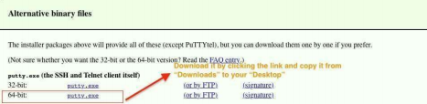

Note:

If your windows system is 32-bit version, please download the 32-bit putty.exe instead.

(2) Go to Desktop and start PuTTY by double-clicking its icon.



(3) When a window of PuTTY shows up, select the Session from the Category panel on the left. In the Host Name field enter the server name

"snowball.cs.gsu.edu". In the Post field keep the default setting "22". Select SSH as the Connection type. Click on Open.

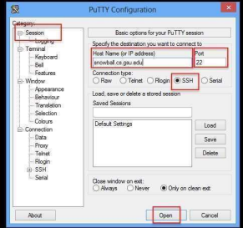

(3) In the new dialog box enter your username and password.



Note:

• The username is your campus ID and the password is the password for your campus ID, which is used to log into your PAWS.

• When you finish typing, press "Enter".

• When entering the password, you will not see the password on the screen. So make sure that you are typing the correct password.

(4) When the following window pops up for the Public Key User Authentication, hit YES.

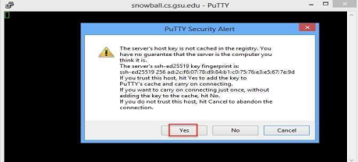

(5) Once you see the prompt "$", you are connected to the server.

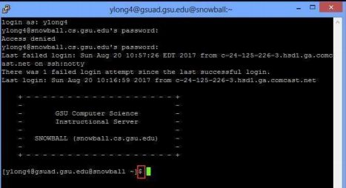 (6) Attach a screenshot like in the figure of step (5) to show that your connection to snowball server has succeeded. Name your screenshot file as

L1_P1_ FirstnameLastname.png (or .jpg). E.g. L1_P1_FilRondel.png Note : Screenshot shortcut in Mac OS cmd + shift + 4; in Windows use snipping tool.

Screenshot:

